- Apostles Creed

- Series Slide

- Since 2001, Found Magazine has been receiving notes, pictures, letters, and drawings that people have found in various places all over the world. The magazine soon turned into multiple book and is now also a website.

- The website is just this collection of randomly found notes and pictures…some funny, some weird, some heartbreaking.

- The note that started it all was mistakenly left on the windshield of the car of FOUND MAGAZINE’S creator back in 2001.

- Apparently his car looked a lot like it belonged to some guy named Mario…and Amber was not happy about finding Mario’s car.

Amazing. 34 words scribbled out on piece of paper. And suddenly…we somehow… see deeply into this guy Mario and this girl Amber…and their tumultuous relationship.

Mario doesn’t seem to exactly be faithful…and Amber doesn’t exactly seem to be trusting. He obviously has hurt Amber before…yet still, Amber has this hope…Like…she doesn’t say “Have a nice life, jerk!”…she says “Page me later” (For you young’ns, we used to carry around these little electronic boxes that only had a screen that would display a phone number. So you could call someone’s pager…and leave a number to call on there…and then they would find a land line- which at that time we just called a “phone”- and then that person was supposed to call you back.) That’s what “page me later” means.

- Its this mix of utter disgust and anger…as well as some sort of co-dependent hope. Like there is still something left for them to talk about. Something left of this relationship.

- Mario and Amber. I feel like I know you.

- All that…from a mistakenly left scrap of paper on a windshield.

- Turns out…that when you look at these notes and pictures…you aren’t just finding the objects themselves…it turns out you’re finding people. Who they are. How they hurt. What their dreams are. What makes them laugh. Sometimes its funny. Sometimes its insightful. Sometimes its weird…sometimes its heartbreaking…sometimes its hopeful. Its people. And people are all of those things. Sometimes in a single note.

- Lets just look at some examples:

- Here’s a polaroid that was found in Dublin, Ireland. Its simply titled “Working”? PIC

- 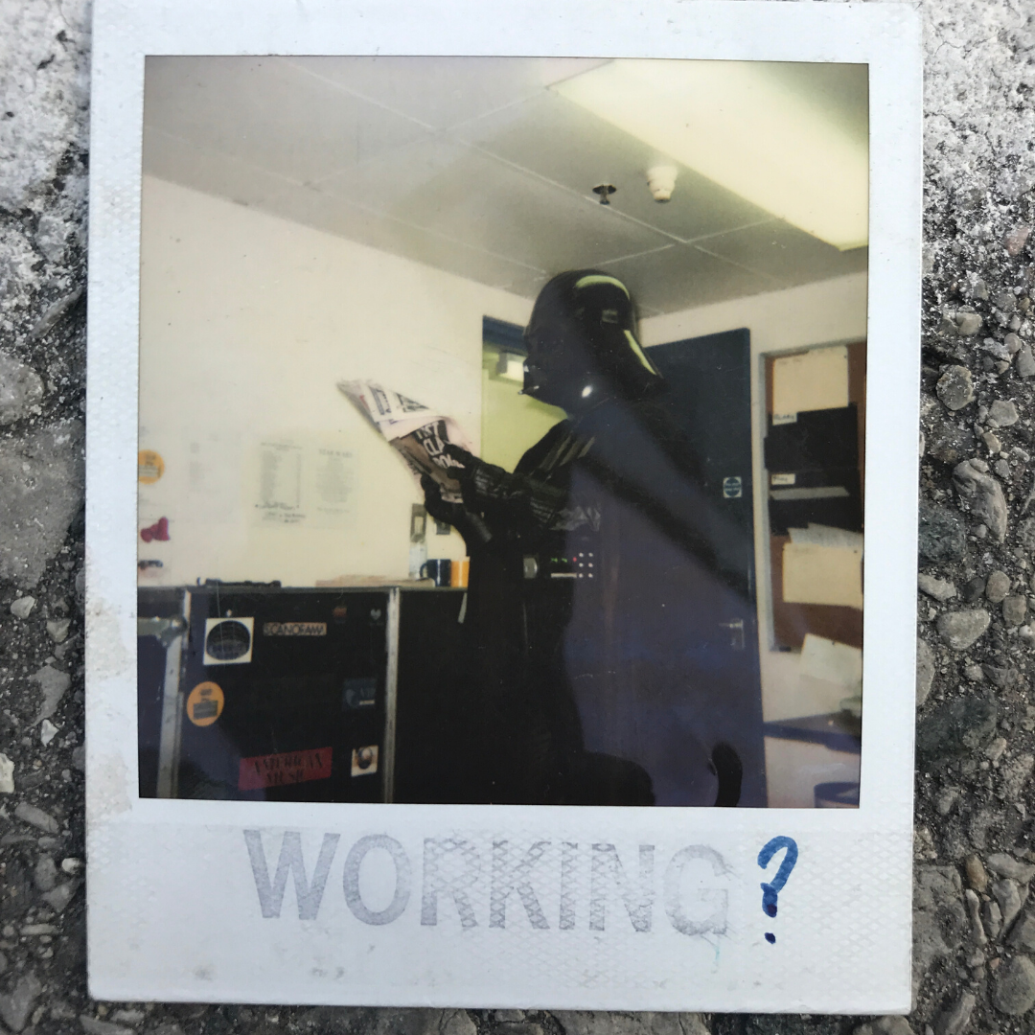
- I mean, good grief. Its like a little window inside of some of office building in Dublin- where a guy is dressed like Darth Vader reading a newspaper. I don’t know who is in that costume…but just because he’s in the costume…and someone has obviously stamped “working” with a ? at the bottom of it …I want to submit a resume to this place and “work” there.

- Now, you may say, “Don't we have this now on Social Media?”
- And I would reply to you…absolutely not!

- Not even close.

- What makes the notes and pictures collected in “Found Magazine” profoundly different from what you find on a Instagram or Facebook Scroll…is that the vast majority of these were not meant for public consumption. When you post something to Social Media…you know you’re performing. You know you have an audience…and JUST THAT FACT ALONE…triggers something in your brain to change and adjust the way you present.

- But for most of these notes and pictures…they are intimate. They are intended for communication between 2 people….or in Irish Darth Vader’s case…for a group of office pranksters.

- When I look at Found…I know I’m not looking for someone clambering for public validation, rather…I’m looking at someone’s inner thoughts and personality. Not something we get a whole lot of these days.

- Let me show you a few more. PIC

- 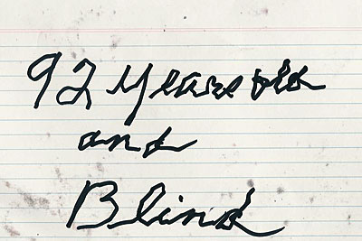

- This one was mailed in from Canada from a lady that worked in the Census office. Apparently, a 92 year old person received the survey…but obviously couldn’t fill in all the bubbles, so in a sort of cheeky, but impressive manner she writes out “92 years old and blind”. Why didn’t she just get the person who told her that the piece of mail was a census to fill in the bubbles for her? I don’t know, but this person thought his government was only entitled to 2 pieces of information. Her age, and her inability to see. But this government worker got treated to so much more. The deep resolve of this person over 92 years of life to both keep up her sense of humor and writing ability…even in the challenge of blindness. (BTW her cursive is about 5 times better than mine)

- Here’s one simply entitled “The Thespian”

- Again, I don’t know this guy…but now I WANT TO!

- Or sometimes, there’s notes like this. From an 18 year old boy probably a freshmen in college written in his journal on New Years Day in 2008. Apparently, some guy is dating the girl he wants to date…and so, naturally it's the end of the world.

- 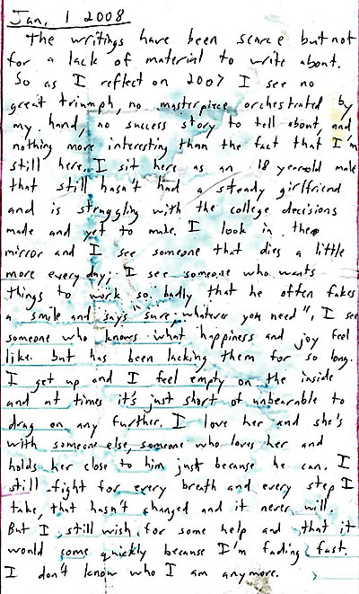

- “I get up and feel empty on the inside and at times its just short of unbearable to drag on any further….I still fight for every breath and every step I take…(Sting Reference!!!)…But I still wish for some help and that it would come quickly because I’m fading fast. I don’t know who I am anymore.”

- I don’t know this guys’ name…but I’ve seen him. In this note, I’ve found him. At least as he was in 2008.

- He’s 29 or 30 now. I wonder how he’s doing? I hope he found out who he is.

- This next note was found near one of those Angel Trees that go up around the holidays. Where kids write down what they want for Christmas and then you can purchase gifts according to that wishlist to send to them.

- But Luca’s wish, could not be granted that Christmas.
- 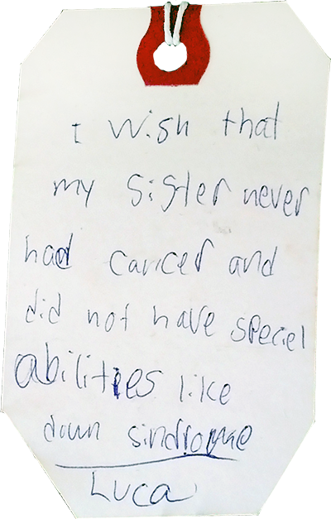

- Here’s one final one. Believe me, I could keep going for a long time.

- This is a napkin found by a waiter who was cleaning up at a TGI Fridays in England.

- 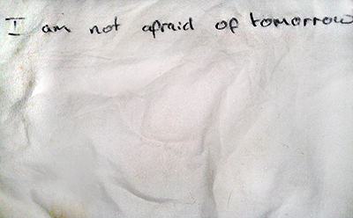

- Is it a message somebody wrote to themselves?
- Was it a declaration to the world?

- Here’s the thing…the only way anybody writes down they are not afraid of tomorrow is if they are in a battle with the fear of tomorrow. Did he mean the future? Did he mean literally tomorrow? We don’t know. But we know the person who wrote this was a in a battle. We know they were desperate because they were in a TGI Fridays writing a note like this. I’m strangely, proud of this person. I don’t have anything other than 6 words on a napkin…but I’ve found this person…I’ve seen this person…if only for a brief moment…I’ve heard this person.

- Title Slide “Found: What Its Like to See and Be Seen by Jesus”- John 1:19-51

- The passage we’re looking at today from John’s Gospel is a passage about a voice that’s crying out in the wilderness…and being heard. It's a passage about being seen…and seeing. It's a passage about finding and being found.

- It's a passage about people finding Jesus…and Jesus finding people.

- It gives us deep insight into who Jesus is…and in turn… who we are.

- John 1:19-51
- 19 This was John’s testimony when the Jews from Jerusalem sent priests and Levites to ask him, “Who are you? ”

- 20 He didn’t deny it but confessed: “I am not the Messiah.”

- 21 “What then? ” they asked him. “Are you Elijah? ”

- “I am not,” he said.

- “Are you the Prophet? ”

- “No,” he answered.

- 22 “Who are you, then? ” they asked. “We need to give an answer to those who sent us. What can you tell us about yourself? ”

- 23 He said, “I am a voice of one crying out in the wilderness: Make straight the way of the Lord ​— ​just as Isaiah the prophet said.”

- 24 Now they had been sent from the Pharisees. 25 So they asked him, “Why then do you baptize if you aren’t the Messiah, or Elijah, or the Prophet? ”

- 26 “I baptize with water,” John answered them. “Someone stands among you, but you don’t know him. 27 He is the one coming after me, whose sandal strap I’m not worthy to untie.” 28 All this happened in Bethany across the Jordan, where John was baptizing.

- 29 The next day John saw Jesus coming toward him and said, “Here is the Lamb of God, who takes away the sin of the world! 30 This is the one I told you about: ‘After me comes a man who ranks ahead of me, because he existed before me.’ 31 I didn’t know him, but I came baptizing with water so he might be revealed to Israel.” 32 And John testified, “I saw the Spirit descending from heaven like a dove, and he rested on him. 33 I didn’t know him, but he who sent me to baptize with water told me, ‘The one you see the Spirit descending and resting on ​— ​he is the one who baptizes with the Holy Spirit.’ 34 I have seen and testified that this is the Son of God.”

- 35 The next day, John was standing with two of his disciples. 36 When he saw Jesus passing by, he said, “Look, the Lamb of God! ”

- 37 The two disciples heard him say this and followed Jesus. 38 When Jesus turned and noticed them following him, he asked them, “What are you looking for? ”

- They said to him, “Rabbi” (which means “Teacher”), “where are you staying?”

- 39 “Come and you’ll see,” he replied. So they went and saw where he was staying, and they stayed with him that day. It was about four in the afternoon.

- 40 Andrew, Simon Peter’s brother, was one of the two who heard John and followed him. 41 He first found his own brother Simon and told him, “We have found the Messiah” (which is translated “the Christ”), 42 and he brought Simon to Jesus.

- When Jesus saw him, he said, “You are Simon, son of John. You will be called Cephas” (which is translated “Peter”).

- 43 The next day Jesus decided to leave for Galilee. He found Philip and told him,“Follow me.”

- 44 Now Philip was from Bethsaida, the hometown of Andrew and Peter. 45 Philip found Nathanael and told him, “We have found the one Moses wrote about in the law (and so did the prophets ): Jesus the son of Joseph, from Nazareth.”

- 46 “Can anything good come out of Nazareth? ” Nathanael asked him.

- “Come and see,” Philip answered.

- 47 Then Jesus saw Nathanael coming toward him and said about him,“Here truly is an Israelite in whom there is no deceit.”

- 48 “How do you know me? ” Nathanael asked.

- “Before Philip called you, when you were under the fig tree, I saw you,” Jesus answered.

- 49 “Rabbi,” Nathanael replied, “You are the Son of God; you are the King of Israel! ”

- 50 Jesus responded to him, “Do you believe because I told you I saw you under the fig tree? You will see greater things than this.” 51 Then he said, “Truly I tell you, you will see heaven opened and the angels of God ascending and descending on the Son of Man.”

- Transition:
- What we just read carries the answer to the quandary of that 18 year old freshman who wrote “I don’t know who I am”.
- It holds the hope for that wishing tree child who didn’t want his sister to have cancer or Down Syndrome.
- And its EXACTLY what’s needed to create the boldness in you to write down on a napkin EVERY SINGLE DAY…”I’m Not Afraid of Tomorrow”.

- This Scripture affirms something that, if you stop for a minute, we all know about ourselves.

- 1) We all want to be found, but we’re afraid to be seen.
  - This first chapter of John is packed to the brim with statements of identity and being seen.

  - V 18
  - John’s prologue, that we looked at last week, ends with this statement that no one has “Seen” God, but in Jesus Christ, God has been “revealed”…or “made himself known” to us.

  - Then immediately we get taken into this description of events surrounding John the Baptist

  - V 19
  - In 4 verses at the beginning of this section, John the Baptist is asked 5 times in one form or another by the Jewish priests and Levites, “Who are you?”

  - V 29
  - Then, when John introduces Jesus…This version says “here is the Lamb of God” but the word there is “BEHOLD” which is a word that means “see” or “look at”. …and then he describes Jesus’ identity as the one who takes away the sins of the world.

  - Then at least 5 more times in this story of Jesus’ baptism, John writes about Jesus being “Seen” and “Known”.

  - V 36
  - The next story, John the Baptist is standing with two of his own disciples and Jesus passes by and John writes that he LOOKED at Jesus and told his disciples to LOOK at Jesus.

  - V38-39a (end at Come and See)
  - Then Jesus sees them, asks them “what are you looking for?” and then invites them to Come and SEE.

  - V 41-42
  - When Andrew begins following Jesus, he goes on a search for others to see Jesus.
  - He first FOUND his brother Simon.
  - And he brings Simon so he can FIND the identity of Jesus, that he is the Christ or Messiah
  - Then when Simon FINDS Jesus, JESUS SEES SIMON.
  - And he gives him an identity. You aren’t Simon anymore…you will be known as the ROCK, CEPHAS PETER.

  - It's a statement of changed identity. Simon thought he was finidng Jesus, but Jesus was finding him. Jesus SAW HIM and FOUND HIM.

  - V 43
  - Jesus FOUND Philip
  - And here is an interesting story that really gets to the root of being found and seen

  - V 45
  - After Jesus finds Philip, Philip Finds Nathanael and tells him “we have FOUND the Messiah that Moses and the prophets told us to look for.

  - And he tells Nathanael that Jesus is from Nazareth.
  - Now, look at Nathanael’s response
  - V 46
  - He says “Can anything good come out of Nazareth?” in other words, Nazareth doesn’t produce Messianic candidates. It produces people who’s greatest achievement in life is belching the alphabet and crushing beer cans on their forehead.
  - And Philip invites him to “Come and see”

  - V 47
  - The next verse says that Jesus SEES Nathanael.
  - In a literal sense, he sees him coming…but in a figurative sense…he SEES NATHANAEL.

  - Jesus says “Here truly is an Israelite in whom there is no deceit.”
  - Now, this is a throwback reference to Jewish ancestry. Particularly to a guy from the book of Genesis named “Jacob”. Jacob…whose name means “deceiver”, met God in the wilderness…at his lowest point…all alone…all of his lies and deceit had caught up with him…and he wrestles with God…and God gives him a new name. ISRAEL. Which means “to Struggle with God”

  - So Jesus references something from Genesis where God met with someone and was seen…and in that encounter changed that persons’ identity.

  - It's a very poetic statement.
  - V 48
  - So Nathanael- feeling pegged by Jesus asks “How do you know me?
  - And Jesus answers, “Before Phillip called you, when you were under that fig tree, I saw you.”

  - Now, right here at this point, Nathanael feels like he just left his note for Mario on Jesus’ windshield by mistake.
  - He feels seen. Exposed.

  - What Jesus means here is not merely that he had a vision of Nathanael sitting under a fig tree…though that may be the case.
  - He means he SAW Nathanael on a deeper level. In fact, something about this Fig Tree is very revealing.
  - It was said at this time in Rabbinic tradition that Rabbi’s would study the law underneath a Fig Tree (NAC). So basically, Jesus caught Nathanael reading his Bible. Jesus SAW NATHANAEL when he was SEEING GOD through the WORD.

  - Nathanael, you were looking at God’s word. Well, now the WORD of GOD is looking at you.

  - V 49
  - So Nathanael makes an identity statement about Jesus “Rabbi! You are the Son of God! The KING of ISRAEL!”

  - V 50-51
  - Jesus says, “that impressed you?” Literally, “you ain’t SEEN nothing yet.”

  - Jesus says “truly, I tell you” which in the book of John when Jesus says this its like him saying- “Don’t miss this…here’s the point”
  - And he says that you will see heaven opened and the angels of God ascending and descending on the Son of Man.”

  - This is a double throwback reference to the Hebrew Scriptures. Something that Nathanael…a man who seems to have dedicated himself to studying those Scriptures, knows very well.

  - First, the angels ascending and descending are a reference back once again to Jacob. On a different night when Jacob was out in the wilderness alone, running for his life because of his deceit…God sent him a vision of a staircase that led up into heaven on which angels were climbing up and down.

  - Gen 28:16 & Daniel 7:13
  - When Jacob awoke from that dream he said “Surely the LORD is here, and I didn’t KNOW IT”

  - Again, Jacob was sleeping…and though he couldn’t SEE GOD there, God saw him.

  - The other reference to the Son of Man is reference to the OT prophetic book of Daniel.

  - Daniel sees this one called the son of Man, who comes on the clouds and is set up as a King.

  - Two different VISIONS of God, where God surprised someone by showing up.
  - One that redefined the identity of Jacob…the other that gave Daniel an expectation of what it would be like to SEE GOD.

- Back to 1)
  - In fact, in this opening chapter of John, Jesus gets 7 titles ascribed to him.
  - 7 observations from others about his identity.
  - Lamb of God
  - Son of God
  - Rabbi
  - Messiah
  - Son of Man
  - King of Israel
  - Jesus of Nazareth

  - All 7 of these identity statements happen to be true of Jesus, but they all come from people who SEE Jesus.

  - The number 7 has special significance for Hebrews...its a number of perfection and completeness.

  - 7 times in the book of John, Jesus will answer a statement about his identity with the phrase “I AM”- which is what God called himself in the burning bush.

  - 7 times Jesus will make statements where he says “I AM” and then follows it with a direct object. Like “I AM the bread of life.” Or “I am the vine”. Identity statements.

  - Then there are 7 signs that Jesus performs in the book of John. Like turning water to wine. Each time one of these signs is performed…there is misunderstanding about Jesus’ identity.

  - John is very cleverly and thoughtfully telling us that we are going to get a complete picture of Jesus’ identity…
  - …and we’re going to get that through the way he sees people…and the way people see him.

  - Listen, All of us want to be to found.
  - We all want the answer to the question “Who am I? Really, who AM I? And why does it matter that I’m here?”

  - We want the kinds of experiences that Simon Peter and Nathanael have here. We want the kind of experience Jacob had. Where God shows up and says, “THIS IS WHO YOU ARE. I KNOW WHO YOU ARE AND THIS IS YOUR FUTURE.”
  - We want to be able to write on a napkin “I'm NOT AFRAID OF TOMORROW. I KNOW WHO I AM. I KNOW WHERE I'M HEADED. AND NOTHING IS GONNA STOP ME”

  - But, at the same time, we don’t really want to be seen. Sure, we want to be noticed. We post pictures of ourselves…and we tweet or post thoughts on Facebook. But those are all intended for us to be noticed…not really seen.
  - We’re terrified of being seen. We’re terrified of confession of sin. Terrified of letting others in to the deep places of our minds and hearts.
  - Like, if you happened to be the 18 yr old college freshmen that wrote the journal entry that I put on the screen earlier… …you’d feel very exposed right now. Its very uncomfortable. Painful.

  - Kind of like Nathanael under that fig tree. Taken off guard.
  - But, you cannot be known, without being seen.
  - You cannot be found, until somebody sees how lost you are.
  - Until you’re exposed…you can’t really be loved.

  - See, if someone loves you, but they don’t really KNOW you...they haven’t really SEEN who you are yet…then that love is cheap. Its shallow. Its superficial. It's a birthday wish on Facebook.

  - And so, we’re left with this quandary in all of our relationships…
  - We want to be loved and accepted. We want to be found. But we don’t want to be SEEN.

  - Then in comes Jesus. And he’s just walking up to people saying, I’ve seen everything you’ve ever done. Everything you’ve ever thought. And then he commits to give them a brand new identity. Then he says, “Follow Me”.

  - Jesus comes in saying, “If you will look at me. If you will behold the lamb of God who takes away the sins of the world. If you will follow me, watch me…I’ll show you what I see when I look at you.”

  - I turned Jacob to Israel.
  - I turned Simon into a Rock.
  - I take Nathanael who was just reading the word….and now…he gets to WALK with the WORD.

  - Jesus comes saying, “I see you. I love you. I know you. I found you. I’ve read your notes. I’ve seen your pictures…that you thought no one else has seen. WORKING?

  - Jesus says, “I’ve not only seen the future. I am THE FUTURE. And I’m NOT afraid of tomorrow…and neither should you be.”

  - Listen, if you don’t define your identity through GOD, there are only 2 other ways to do it. There are only 2 other ways to “FIND YOURSELF”
  - One, is you can define yourself through the way other people see you.

  - This is a traditional understanding of identity. You are sort of the roles you play in your community. You are primarily a mother, a father, a brother, a sister. A Friend.
  - You’re identity is your job. You are a policeman, or a stock broker, or a carpenter, or an IT guy.

  - Therefore, being a good person…a person of value… is determined by how well you perform these roles in your community. It comes from your social standing in the eyes of the people that see you.
  - The problem with defining yourself through your roles in the community is that at some point, your kids leave home…and you don’t really feel like a Mom anymore.
  - At some point, you have to retire from the force, and you don’t really feel like a policeman anymore.

  - Most retired people will tell you, there is a sense that when you stop doing the thing that for so long defined your identity…it sort of feels like no one sees you anymore. You lose a sense of meaning and importance because for the better part of your life, you understood WHO YOU WERE by HOW others saw you.

  - The other way to “find yourself” is the modern western way.
  - That is you sort of decide for yourself who you are. It doesn’t matter what other people think. If you think you are a rock star…it doesn’t matter that you can’t sing…don’t let people hate on you. Chase your dreams.
  - You find yourself not by looking to the community outside you…instead you tell the community who you are. Which mainly comes from how you feel deep down on the inside.

  - The problem with this approach is that we deeply need all of our identities to be verified by someone outside of us.
  - No one is ever content just defining themselves. When you yell from the mountaintop, “I’m smart. Or I’m cool. Or I’m trendy. I’m funny. That will never be enough for you. You will always have to prove it…and then have it affirmed.”
  - You need somebody to hear that voice. You need somebody to yell back, “YASSS QUEEN!” or “YOU GO BOY!” or “YOU DO YOU”.
  - We aren’t ok just screaming our identity into a void…we’ve got to have someone echo back- “YES! I AFFIRM YOU!”

  - The idea that we don’t care what people say about us is simply false. That’s where all our self-appointed identities fall apart. Ultimately…we always end up craving someone saying, “I see you. I Know you. And I agree…you are who you say you are.”

  - The only other way to define yourself, is to have God define who you are.

  - Like Jesus comes in looking at Simon, and says “I see you…do you see me? You’re not a fisherman…you’re a rock….and upon this rock I’m going to build my church.”
  - He goes to Nathanael and says, “Nathanael, I know you get a lot of pride from being a true Israelite who studies the Scripture…but I’m telling you…You ain’t seen nothin’ yet. You are about to enter into a relationship with the very word you’ve been reading about. And THEN…then you’ll figure out who you really are.”

  - Its only a God-defined identity…it is only by being seen and seeing Jesus that we get an identity that’s bullet proof. One that no matter what happens to us…even if the world doesn’t echo back “YOU GO BOY”….even if everyone of our community deserts us…when God defines your identity…you don’t have to be afraid of tomorrow.

- Transition: We see this more clearly in John the Baptist than an any other character.

2) When you see Jesus as the Lamb of God, you’ll lose yourself in humility…and find yourself in boldness.

  - If you were the author of one of those notes on Found Magazine’s website…and you knew that the world was reading it online…there are a couple of things that happen to you.

  - First, you feel extremely humbled. Not like in a “Wow, I just received and Oscar and I’m so humbled” kind of way…but in a humiliated sort of way.

  - You feel exposed. Like people are seeing a part of you they were never supposed to see.

  - On the other hand, there is a new kind of boldness.

  - Because whatever it is you were trying to say. Its now out there. Your voice is being heard by the world. Whether it's the voice of struggle of that 18 yr old college freshman…or the voice of pain from Mario’s infidelity…or the voice of confidence “I’m 92 and Blind”- “I’m not afraid of tomorrow”.

  - Thespian photo
  - Like the Thespian, with his masks suddenly removed (and then hung on his wood paneling) You are exposed…

  - And you see this clearly in John the Baptist.

  - V 21-22
  - When John the Baptist is asked 5 times who he is…notice that he just keeps saying who he ISN’T.

  - Is he the messiah? Is he the Elijah figure the OT predicted? Who does this guy think he is?

  - John keeps sort of minimizing himself. Finally when these priests ask him “What can you tell us about yourself?”

  - V 23
  - He answers back with a quote from the prophet Isaiah.
  - I am a voice crying out in the wilderness; Make straight the way of the Lord.

  - In other words, If you found a note that John the Baptist wrote…it wouldn’t be about him at all. It would be about Jesus.
  - John has reduced his life down to being a voice. His purpose to being a voice that announces Jesus.

  - This is very interesting, because even Jesus sees him a little differently.

  - Matt 11:11a (End at “appeared”)

  - Jesus himself says that John the Baptist is the greatest human being that has ever lived.

  - But when John is asked, he doesn’t see himself like that.

  - He simply sees himself as a voice, announcing Jesus’ arrival.
  - V 27
  - He says that no one should be wasting their time trying to figure who John is, rather, they should spend their time trying to see Jesus is.

  - John says that he is not fit to unstrap Jesus’ sandal.
  - This is a cultural statement.
  - One of the lowest things, only the most lowly servant could do was to take off his master’s shoe.
  - In other words, most people were TOO FIT. TOO IMPORTANT. TOO HONORED. To take off someone’s sandal.

  - John the Baptist says, “I’m not even fit for that job, when it comes to Jesus.”

  - Listen, don’t confuse John’s humble statements with low self-esteem.
  - See, even having low self-esteem…is still focused on self. Its not humility…its looking at yourself and thinking about your self. Sure, negatively, but its still self-focused.

  - That’s not what is happening with John.

  - V 32-33
  - John is looking at Jesus.
  - John isn’t wandering around looking for his own self-identity. He has forgotten himself, because he has seen God the Father’s identity statement about Jesus.
  - He recounts Jesus’ baptism here, where a dove descended on Jesus…and Jesus’ own identity was revealed from outside of himself. The Father said ‘This is my son with whom I’m well-pleased. God the Father told John that Jesus was the one who would transform people with the Holy Spirit.”

  - And this is what made John so Bold.
  - I mean, he’s incredibly humble, but at that same time, ridiculously bold.

  - V 24-25
  - You know, the whole reason why these Priests and Levites are out here in the desert asking John the Baptist what he’s doing, is because they had been sent by the Pharisees.
  - The Pharisees were very concerned about what John the Baptist was doing, because it was extremely bold.

  - See, in the Jewish faith at this time, the only people who needed baptism were Gentiles who were taking up the Jewish faith. If you were a Jew by ethnicity, you didn’t baptism. Because it was a cleansing ritual.
  - And the Pharisees were VERY HIGH on themselves…for being distinct from Gentiles.

  - But John was baptizing EVERYBODY. Jews AND Gentiles. John’s baptism was saying, “Everybody needs cleansing. Everybody needs washing. Everybody is Mario…an unfaithful cheater on God

  - This was a statement even to the high-on-their-horse religious Pharisees…you have to be washed just like the Gentiles…you have sin that needs cleansing. You aren’t any better than anyone else.

  - John’s boldness continues all the way to his death. When he is thrown in prison and eventually beheaded because he tells King Herod to his face that its not right for him to marry his brothers wife.

  - So here’s the question. What is it that John the Baptist saw about Jesus that makes him on one hand…completely forget himself… on the other hand…this bold voice that just continually exalts Jesus and confronts evil- Speaking truth to power. Unafraid. All the way to the guillotine.

  - V 29
  - Well, its not just THAT he sees Jesus…it's HOW he sees Jesus.
  - I told you before, there are 7 names that are given to Jesus in this narrative section of chapter 1. There are 7 statements of his identity.
  - Son of God
  - Rabbi
  - Messiah
  - Son of Man
  - King of Israel
  - Jesus of Nazareth

  - All of those are good names. True statements of Jesus’ identity. From Rabbi-Teacher…to Son of God…or Anointed one.
  - There are titles of power and majesty, like the Son of Man from Daniel coming in clouds. Or the Royal title of King of Israel. Or the anointed one, Messiah. Son of God…titles that emphasize his divinity.

  - There are simple titles like Rabbi (or teacher) and Jesus of Nazareth…that emphasize his humanity.

  - But only John the Baptist recognizes Jesus as the Lamb of God who takes away the sins of the World.

  - And that’s important.
  - See if Jesus is only divine…only powerful…he stands only as judge over us. He is only different and better than us.

  - If Jesus is just a teacher or a man from Nazareth… then he is just a sort of better version than us…but really can’t do anything about our spiritual blindness…he can’t really guarantee us a Fearlessness as we stare into the future. He can’t guarantee that its safe to take off our masks that hide us…nail them to our wood paneling…and stand there in front of God…permed hair and all.
  - He can’t guarantee that when we stand before God fully exposed…that we won’t fall over dead…ashamed and embarrassed.

  - But, because John saw him as the Lamb of God that takes away sin…he became this self-forgetful…but JESUS focused…humble and bold VOICE.

  - Do you know what that means…that Jesus is the Lamb of God. And that you should look at him like that?

  - It's a reference to the Passover that the Jews celebrated.
  - In the book of Exodus, there’s a story about the Hebrew people being led out of Egyptian slavery by Moses.
  - Moses, acting as a voice for God, goes to pharaoh 10 times and says, “Let my people go!” But 9 times, Pharaoh reneges on his promise to let them go, so God sends a plague on Egypt.

  - But, the final plague, the one that finally gets Pharaoh to release God’s children…God says that the angel of death will sweep through Egypt…and that the Angel of Death will kill every firstborn son.

  - And the angel would do this indiscriminately. Sort of like John’s baptism. It didn’t matter whether you were Jew or Gentile…the Angel of Death would come for everyone’s firstborn.

  - The only hope to save your firstborn son, was to kill a lamb, and paint his blood on the frame of your door.

  - So it happened. And Pharaoh, in sorrow and anger, releases God’s children out of slavery. So, it was said, they were saved from death by the blood of the lamb.

  - When John realizes that Jesus is God’s Son, headed to his death for the sins of the world.…it totally humbles him and emboldens him all the way to his own death…staking everything he has on Jesus being the Lamb of God.

  - And its different for the rest of these disciples. Because they don't quite get it yet.
  - Sure, they see him as Messiah, as Rabbi, even as the Son of God.

  - But its not until the cross of Jesus…and the resurrection of Jesus that they become like John the Baptist. Totally losing themselves in humility…but unafraid- completely bold voice in the face of evil and opposition…just read the book of Acts.
  - After they see the Lamb of God, slain in front of their eyes. …after they realize that Jesus was dying FOR THEM…that God’s son was dying so they could be re-born into a new identity…the children of God…it wasn’t until then that they changed…and became a voice saying to the nations “BEHOLD THE LAMB OF GOD”

- LORDS SUPPER

  - See, there was a dinner one time… it wasn’t at TGI Fridays…but it was on the Thursday night before GOOD FRIDAY. And there was no napkin left behind…but the message certainly was, “I am not afraid of tomorrow.”

  - Jesus, got his disciples together to celebrate the Passover…the Exodus of Israel from Egypt.

  - And Jesus was telling them that he was about to be arrested and crucified. But he would resurrect come Sunday.

  - He took the bread from the Passover feast and said, “This is my body broken for you.” In other words, when you see me, completely humiliated and broken on that cross…you have to understand and believe…its for you. I’m breaking for you. It will be like seeing your sin pulled out in front of you. It will be like posting all your sin in front of the world to see. It will be humiliating, exposing.

  - BUT, don’t look away. Don’t hide. GOD SEES YOUR SIN…and is doing something about it. He SEES you in all of your shame…but loves you enough to die so that you can KNOW him.

  - Then Jesus held up the cup, this is my blood shed for you.
  - The blood of the LAMB.
  - That takes away the sin of the world.
  - Jesus was telling them that death would now Passover them.
  - Because he is the lamb that was sacrificed in their place, now they could have a life of freedom in God.

  - And then he said, “I will drink this cup with you again when I come back and remake the world”

  - He was talking about the resurrection. Not just his own…but the one to come.
  - When Christ returns, and all those who have seen and been seen by Jesus…all those whose identity has been changed from a voice saying “look at me” to a voice saying “Look at Jesus”…all of us will be resurrected into a new Kingdom of wholeness and fullness and beauty….and Jesus said the least in the Kingdom of God is greater…even than John the Baptist…the greatest human who ever lived.

  - The Kingdom of God- Where Luca’s Christmas wish will finally be granted. His sister won’t have cancer or Down Syndrome. And we’ll live a lot longer than 92 and no ONE will be blind anymore. Everyone will have sight. We’ll all finally see each other rightly….no more masks like Darth Vader …hey’ll be hung up on the wall, like the Thespian….completely and utterly seen and loved…even with a terrible perm.
  - And Everyone will be able to look on the fullness of God in all of his beauty…and forever we’ll be able to answer that question. “WHO AM I?” with a joyful and grateful… “WE ARE GOD’s …and HE IS OUR’s!”

- And when you are sure of that kind of resurrection…that kind of rebirth…you can, humbly, yet boldly say…as you take this Lord’s Supper…Just like the Lamb of God did on the night before he died…

(PIC) “I am not afraid of tomorrow”

